Multiple ways to get to Jr High Chapel:
- From the front, facing the church, go to right side (we are above the Fellowship Hall).
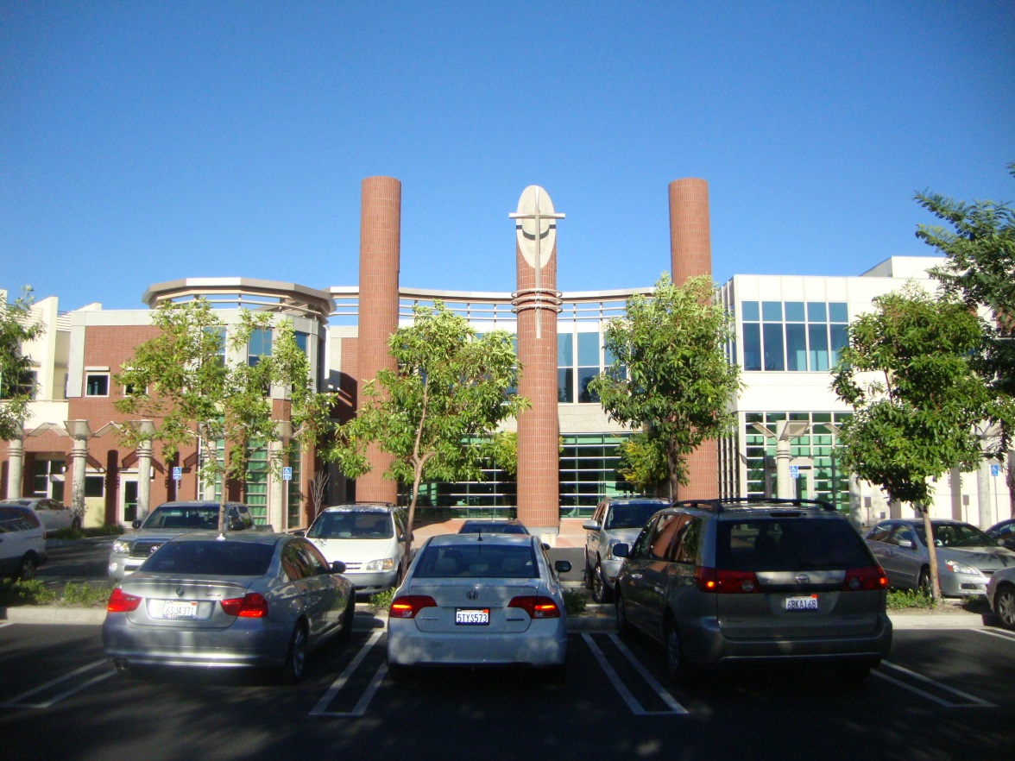

- Here is the door on the right side to the stairs.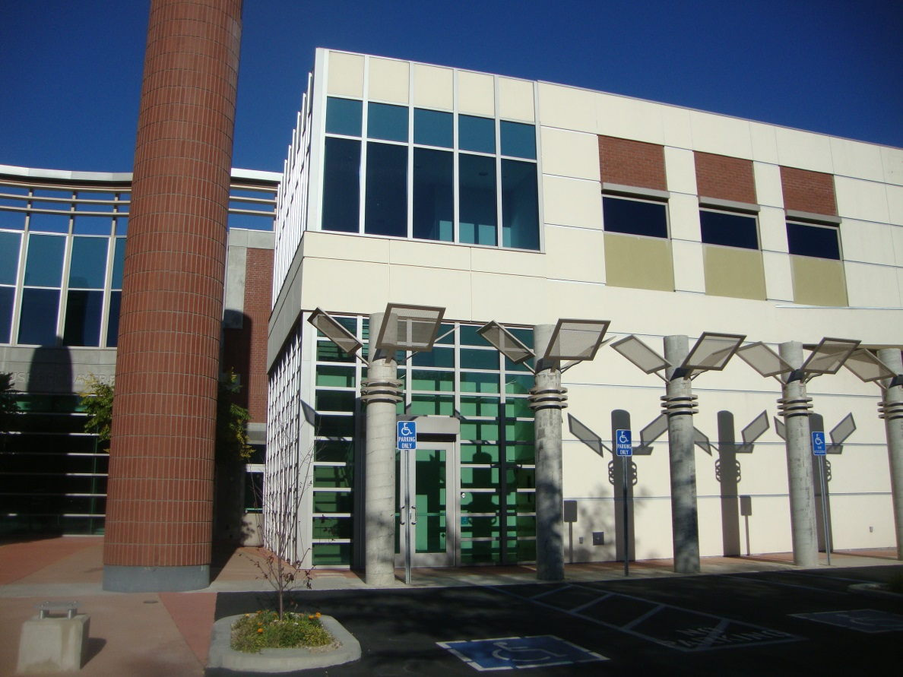

- Walk through the doors, and go up the stairs
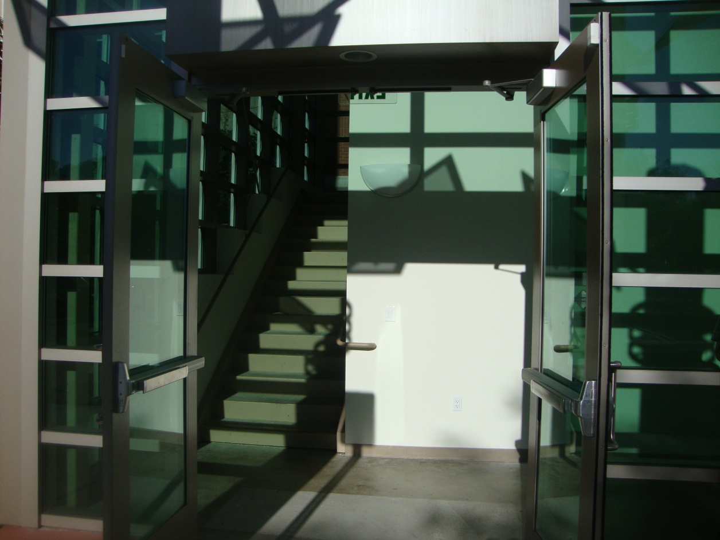
- At the top of the stairs, look right, and you’ll see the hallway.
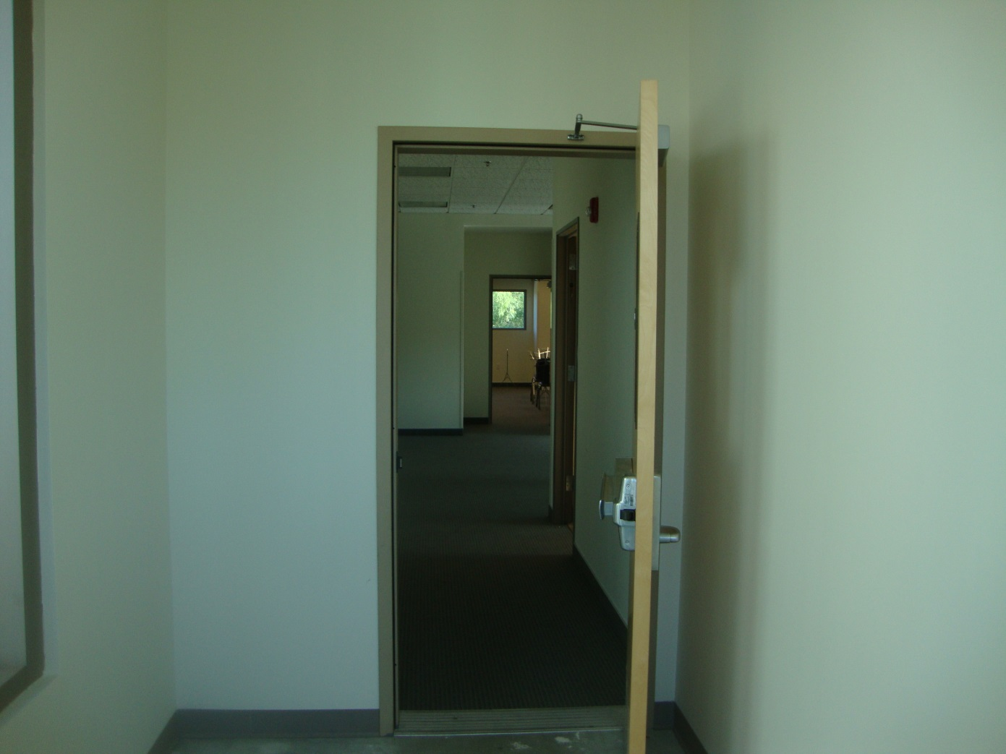

- Keep walking down the hallway.
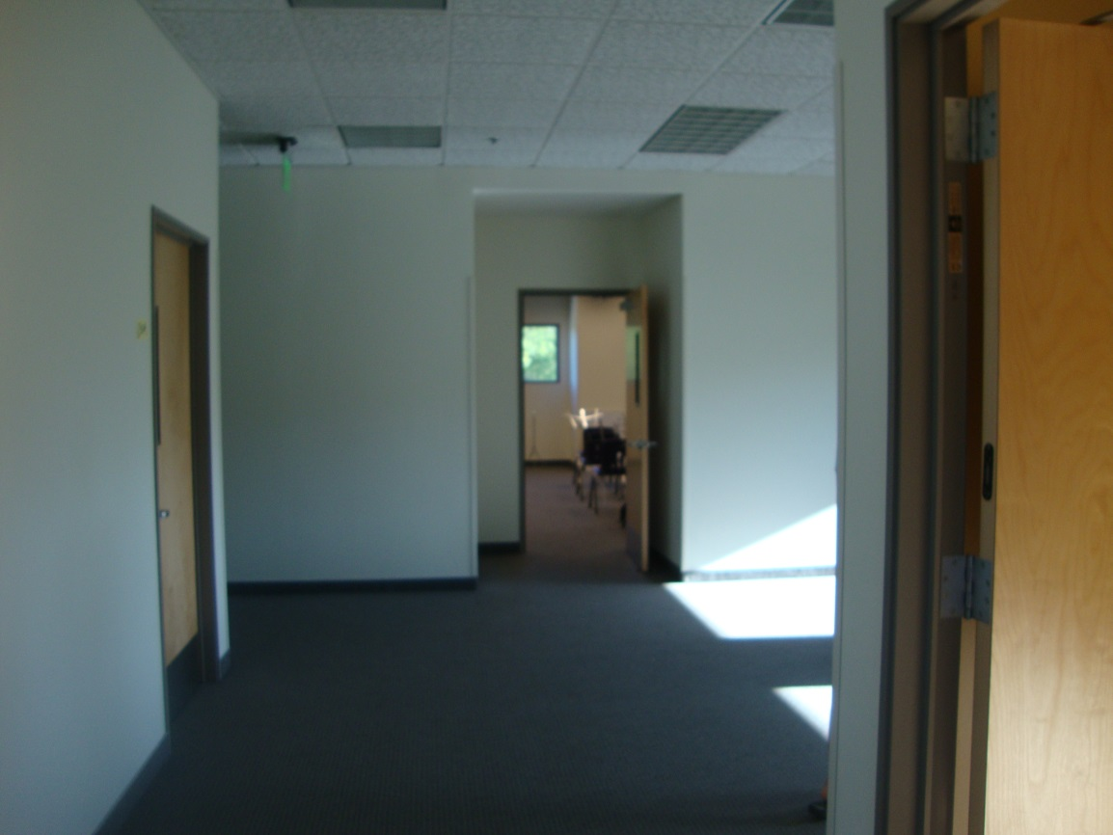
- At the end, make a left turn and go down another hallway to the second to last door on right.
Room 307

- Enter through door Room 307, ESPECIALLY ON SUNDAYS. On Fridays, you can enter through 309 as well.

